**Mahindra First Choice Capstone Project Approach**

**Team Name: Team Viper**

**Team Members:**

Rakesh Kedar: <https://www.linkedin.com/in/rakeshkedar181/>

Pancham Desai: <https://www.linkedin.com/in/pancham-desai-7a9357188>

Vedant Thapa: <https://www.linkedin.com/in/vedantthapa>

Siddhesh Gupta: <https://www.linkedin.com/in/siddhesh-gupta-5b8622197>

**Exploratory Data Analysis for Capstone Project**

**Geolocation Based Analysis.**

**Parts to Labour Ratio:**

* Item Category P001 & P010 were considered for calculating labour charges
* Item Category P002 was considered for calculating part charges
* Item Category P011 was considered for calculating miscellaneous charges
* Grouping the merged data on Year & Item Category we got aggregated sum of the net value for each category
* Parts % = Revenue generated by parts charges(year) /Grand Total (year)
* Labour % = Revenue generated by labour charges (year) / Grand Total (year)
* Miscellaneous % = Revenue generated by Miscellaneous charges (year) / Grand Total (year)
* Parts to Labour Ratio = Parts Revenue(year) / Labour Revenue (year)

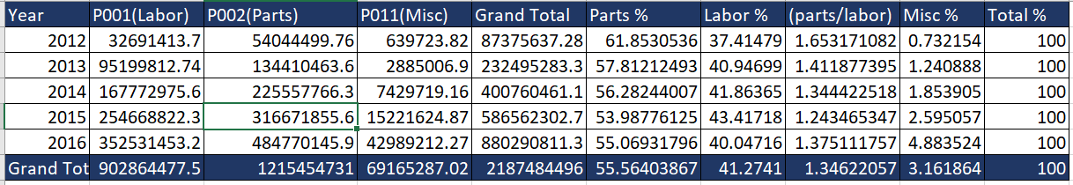

**Efficiency:**

* Efficiency was calculated Plant wise for each year & each month
* Service Time in Hrs was calculated by subtracting Invoice date time & job card date time columns
* Grouped the merged data on Plant, year & month and calculated Avg total revenue,

Avg servicing time in hrs, Count of invoices.

* Efficiency = (Total Revenue in a year / Total servicing time in hrs * Count of invoices) *100

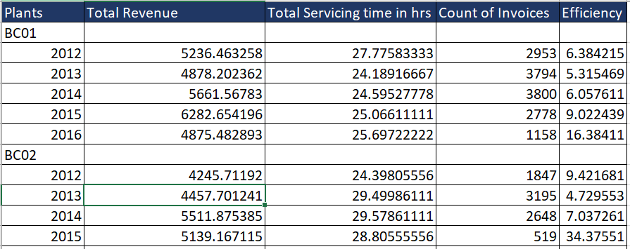

**Data Cleaning and Merging**

After initial analysis of missing values, we had decided to drop below features having missing values more than 40%

* **Invoice Data Cleaning**
  + Dropped Columns: - Amt Rcvd From Custom, Amt Rcvd From Ins Co,

CGST (14%), CGST (2.5%), CGST (6%), IGST (12%), CGST (9%),

IGST (18%), IGST (28%), IGST (5%), SGST/UGST (14%),

SGST/UGST (2.5%), SGST/UGST (6%), SGST/UGST (9%),

TDS amount, Service Advisor Name, Outstanding Amt,

Total CGST, Total GST, Total IGST, Total SGST/UGST,

Policy no., Cash /Cashless Type, Expiry Date, Gate Pass Date,

Insurance Company, Claim No., ODN No, Technician Name',

Regn No',Total Value

* **Customer Data Cleaning**
  + Dropped columns: - Title, Marital Status, Occupation, Date of birth, Death date
* **Jtd Data Cleaning**
  + Dropped columns: - Labor Value Number
* **Data Merging**
  + Joined Customer & Invoice Data on Customer No. (inv_cust)
  + Grouped the Jtd data on dbm order to reduce duplicate order entries (jtd_group)
  + Left Joined the inv_cust with grouped Jtd data (jtd_group) based on job card no & dbm order.
  + Final shape of merged dataframe (inv_cust_jtd)
  + Shape of joined dataframe (936275, 33)

**Feature Engineering**

* **Invoice Date Time**
  + Using Invoice date & invoice time **Invoice_Date_Time** was created
* **Job Card Date Time**
  + Using Jobcard date & Jobcard time **Jobcard_Date_Time** was created
* **Service Time**
  + By Subtracting invoice date time with Jobcard date time
  + Invoice date time – Jobcard date time

**Feature Cleaning**

Following columns were cleaned using pgeocode library of python using pin codes given in Invoice data.

* **City**
  + Using pin code correct city was extracted
* **District**
  + Using pin code correct district was extracted
* **Area/Locality**
  + Using pin code correct location area was extracted

**Customer Segmentation**

After all cleaning & data pre-processing tasks, A new dataframe was created with the help of cleaned merged dataframe (inv_cust_jtd).

Grouping the merged data on Customer No, Cust Type, Make, Model, City, Order Type calculated average servicing time & average revenue & Count of invoices.

**Approach**

* Separating customers with zero spends
  + Separated customers having total revenue <= 0
  + 26327 rows were filtered as zero spenders
* Separating customers with nonzero spends
  + Separated customers having total revenue > 0
  + 284656 rows were filtered as non-zero spenders
* Rule Based Clustering on non-zero spenders using Average revenue
  + 4 clusters were identified based on quantile-based analysis on Average revenue.
  + Low Revenue, Medium Revenue, Average Revenue, High Revenue
* Rule Based Clustering on non-zero spenders using Average servicing time
  + 4 clusters were identified based on quantile-based analysis on Average servicing time in Hrs.
  + Super-Fast, Fast, Super Slow, Slow
* K-means Clustering on non-zero spenders
  + Label Encoded below columns
    - Make, Model, City, Cust Type, Order Type
  + Scaled all the features
    - Using standard scaler scaled all features
  + Used Elbow method to determine optimal no of clusters
    - We tried fitting range of 2 to 12 clusters on the scaled data.
    - Using elbow method, we found 6 clusters as optimal clusters
  + Run K-means clustering algorithm
    - 6 segments were generated by applying K-means algorithm with 6 clusters on scaled data.

**Customer Lifetime Value Prediction**

**Customer Lifetime Value**

Customer lifetime value is a metric that indicates the total revenue a business can reasonably expect from a single customer account. It considers a customer's revenue value, and compares that number to the company's predicted customer lifespan. Businesses use this metric to identify significant customer segments that are the most valuable to the company.

**Customer Lifetime Value Calculation**

CLTV = Customer frequency * Average spend

**Approach For Classification**

* Created a Separate Data Frame for cars over a period of year 2015
* On above Data Frame performed the group by on “Make”, “Model” “Location/Area” and “Customer No.” and perform the count on “Invoice No” (For the frequency of the particular Customer No.) , mean on “Service Time” (For average Service Time), mean on “Total Value” (For average purchase value)
* Multiply Count of Invoice No of individual customer to Average value of the respective customer to get the Customer Lifetime Value.
* Binned the Customer Lifetime value as “Low”, ‘Medium” and “High” to convert it into categorical format.
* Label Encode the Categorical columns.
* Drop columns "Customer No.","LTV (for Running Repairs)","Invoice No" as these columns are not required for Machine Learning Model building.
* Build a Machine Learning model to predict the classification of the customer in to categories of Customer Lifetime as “Low”, “Medium” and “High”. Use different Machine Learning and different features to try and improve the accuracy of the model.

**Approach For Regression**

* Created a Separate Data Frame for cars over a period of year 2015
* On above Data Frame performed the group by on “Make”, “Model” ,’Cust type’, ’Invoice no’, ’district’ and “Customer No.” and perform the count on “Invoice No” (For the frequency of the particular customer no.), mean on “Total Amt Wtd Tax.” (For average purchase value)
* Multiply Count of Invoice No of individual customer to Average value of the respective customer to get the Customer Lifetime Value
* Creating Dataframe for Modelling with features ['Customer No.', 'Cust Type', 'district', 'Make', 'Invoice No', 'Total Amt Wtd Tax.', 'customer_value']
* Renaming features as model_df.columns=['Cust_no.','Cust','State','Make','Count_invoice','Avg_revenue','customer_value']
* Creating a dummy encoded data frame by applying pd.get_dummies() on features [‘Cust’, Make, ’State’]
* Finding the optimal value for Max_depth
* Applying Decision Tree Regressor Algorithm on the features and evaluating the model on different evaluation metrics.